UNITED STATES
SECURITIES AND EXCHANGE COMMISSION
Washington, DC 20549

SCHEDULE 14A
(Rule 14a-101)
INFORMATION REQUIRED IN PROXY STATEMENT
SCHEDULE 14A INFORMATION
Proxy Statement Pursuant to Section 14(a) of the
Securities Exchange Act of 1934
(Amendment No. )

Filed by the Registrant ☒
Filed by a Party other than the Registrant ☐
Check the appropriate box:

☐ |  | Preliminary Proxy Statement
☐ |  | Confidential, for Use of the Commission Only (as permitted by Rule 14a-6(e)(2))
☐ |  | Definitive Proxy Statement
☒ |  | Definitive Additional Materials
☐ |  | Soliciting Material under §240.14a-12
Blaize Holdings, Inc.
(Name of Registrant as Specified in its Charter)
(Name of Person(s) Filing Proxy Statement, if Other Than the Registrant)
Payment of Filing Fee (Check all boxes that apply):

☒ |  | No fee required
☐ |  | Fee paid previously with preliminary materials
☐ |  | Fee computed on table in exhibit required by Item 25(b) per Exchange Act Rules 14a-6(i)(1) and 0-11

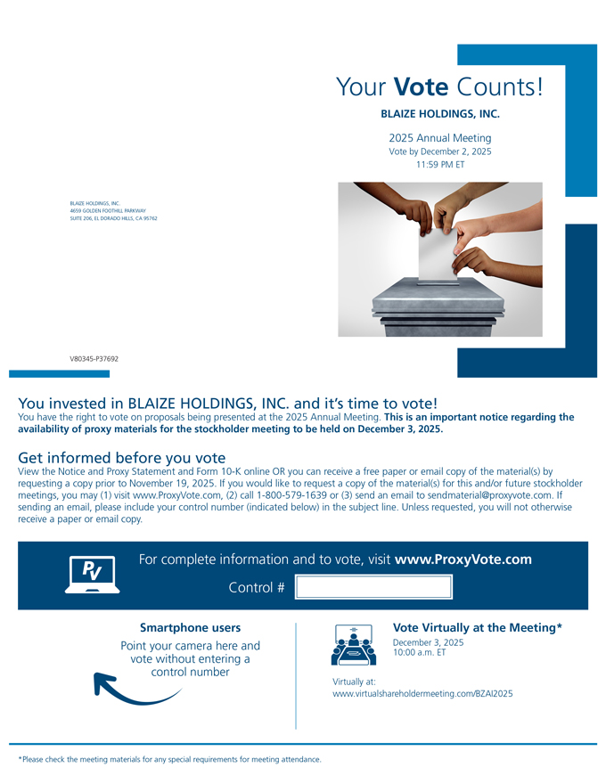
Your Vote Counts! BLAIZE HOLDINGS, INC. 2025 Annual Meeting Vote by December 2, 2025 11:59 PM ET BLAIZE HOLDINGS, INC. 4659 GOLDEN FOOTHILL PARKWAY SUITE 206, EL DORADO HILLS, CA 95762 [Graphic Appears Here] V80345-P37692 You invested in BLAIZE HOLDINGS, INC. and it’s time to vote! You have the right to vote on proposals being presented at the 2025 Annual Meeting. This is an important notice regarding the availability of proxy materials for the stockholder meeting to be held on December 3, 2025. Get informed before you vote View the Notice and Proxy Statement and Form 10-K online OR you can receive a free paper or email copy of the material(s) by requesting a copy prior to November 19, 2025. If you would like to request a copy of the material(s) for this and/or future stockholder meetings, you may (1) visit www.ProxyVote.com, (2) call 1-800-579-1639 or (3) send an email to sendmaterial@proxyvote.com. If sending an email, please include your control number (indicated below) in the subject line. Unless requested, you will not otherwise receive a paper or email copy. [Graphic Appears Here]

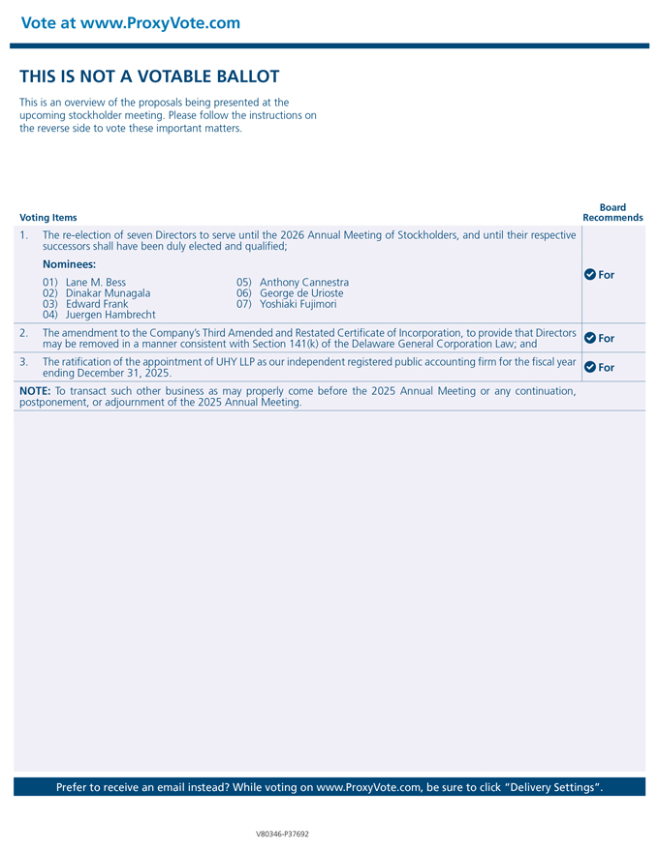
Vote at www.ProxyVote.com THIS IS NOT A VOTABLE BALLOT This is an overview of the proposals being presented at the upcoming stockholder meeting. Please follow the instructions on the reverse side to vote these important matters. Board Voting Items Recommends The re-election of seven Directors to serve until the 2026 Annual Meeting of Stockholders, and until their respective successors shall have been duly elected and qualified; Nominees: For 01) Lane M. Bess 05) Anthony Cannestra 02) Dinakar Munagala 06) George de Urioste 03) Edward Frank 07) Yoshiaki Fujimori 04) Juergen Hambrecht 2. The amendment to the Company’s Third Amended and Restated Certificate of Incorporation, to provide that Directors For may be removed in a manner consistent with Section 141(k) of the Delaware General Corporation Law; and 3. The ratification of the appointment of UHY LLP as our independent registered public accounting firm for the fiscal year For ending December 31, 2025. NOTE: To transact such other business as may properly come before the 2025 Annual Meeting or any continuation, postponement, or adjournment of the 2025 Annual Meeting. Prefer to receive an email instead? While voting on www.ProxyVote.com, be sure to click “Delivery Settings”. 30304-001 20Oct25 10:06 Page 2 V80346-P37692

